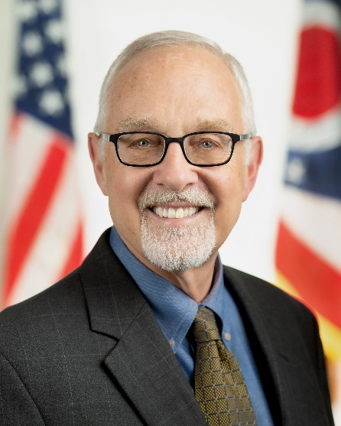
Kirk Herath is currently Ohio Governor Mike DeWine and Lt. Governor Jon Husted’s Cybersecurity Strategic Advisor and Chairman of CyberOhio, the State of Ohio’s Cybersecurity Advisory Board. His role spans coordinating and enhancing the State of Ohio’s cybersecurity capabilities, working with local governments to prepare and remediate cyber-attacks, and helping to build a modern cyber workforce.

Kirk is also an Adjunct Professor of Law at both Ohio State’s Moritz School of law and Cleveland State’s Cleveland-Marshall Law School. He retired as VP, Associate General Counsel and Chief Privacy Officer for Nationwide after 32 years.

For over two decades, Kirk was responsible for all legal and policy issues at a Fortune 100 financial services company impacting data governance, privacy, information security, technology and information systems, contracts and supply services management, third-party risk, confidentiality and data integrity. Kirk has represented clients on many privacy and Cybersecurity policy groups and before legislative and regulatory bodies.

He is Past President and past board member of the International Association of Privacy Professionals. He also served on the U.S. Department of Homeland Security’s Data Privacy and Integrity Advisory Committee from 2005 to 2011.

Kirk received undergraduate degrees in political science and history from the University of Cincinnati and has a master’s degree in international affairs from the American University in Washington, D.C. He holds a JD from Capital University Law School in Columbus, Ohio, and is admitted to the Ohio Bar. Herath is also a Certified Information Privacy Professional/US and Certified Information Privacy Professional/Government.

