Brandon Pugh
Policy Director and Resident Senior Fellow, Cybersecurity and Emerging Threats
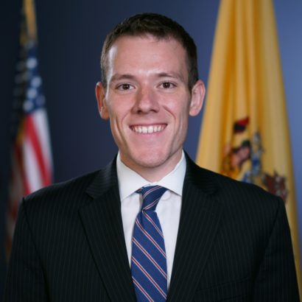
Brandon Pugh is a policy director and resident senior fellow for the Cybersecurity and Emerging Threats team. Outside of R Street, he serves as an international law officer in the U.S. Army Reserve where he worked on the Army Cyber Institute’s critical infrastructure resiliency project. Brandon is also a board member for the Ithaca College Cybersecurity Program and for a governor’s advisory council.
Prior to R Street, Brandon was legislative counsel for the New Jersey General Assembly Minority Office, where he handled nearly all policy and legislation on cybersecurity, emerging technology and privacy for the office. He also provided legal and policy advice to the 28-member caucus on almost every committee area from judiciary to commerce.
Brandon also served as a fellow with the Federal Bureau of Investigation, the managing editor of the Journal of Law and Cyber Warfare, the president/CEO of a homeland security advisory company, a board member on the Rutgers University Cybersecurity Program Board, and an elected and appointed official at the local, county and state level. This includes service as the vice president for legislation of the New Jersey School Boards Association, which is a quasi-governmental entity representing New Jersey’s nearly 600 school boards.
Brandon has presented and been published dozens of times, including training congressional staff on cybersecurity, authoring a report on national preparedness training, preparing cybersecurity guidance sent to thousands of public schools, and leading events with senior military and intelligence community officials. He has been awarded multiple times for his work by members of Congress and a governor of New Jersey, among others.
He received a JD from Rutgers Law and a BA from The College of New Jersey. Brandon is a master continuity practitioner through the U.S. Department of Homeland Security and is a certified information privacy professional. He is licensed to practice law in New Jersey.
Brandon lives in New Jersey with his wife, who serves as an Air Force pilot.

